

##### Ag World International

Ag World's primary goal is to supply the highest quality animals at the most competitive price. Furthermore, we aim to provide superior service both before and after shipment to guarantee a satisfied

customer. Only through reaching our primary goal can we generate profitable growth while maintaining our status as a financially secure, well-managed, ethical company.

Ag World can supply genetics for all species through live animals, embryos, or semen. We are committed to exceeding our customers' expectations through our rigid selection process, health testing, final

inspections, and follow-up service. This insures satisfied customers and Ag World's growth through word-of-mouth sales and repeat customers. Together, the employees of Ag World have built the most preferred livestock exporting business in the United States.

Each of our customers has specific and unique needs that must be addressed. We can fulfill those needs through our worldwide sources by supplying the genetics required to maximize production and profits for each individual customer. We are not limited by any one farm or any one country to provide the genetics you need. Ag World is your global source for profitable genetic material.

##### Ag World International

OcHOBHOH u,enbio KOMnaH1111 Ag World RBm1eTcR nocTaBKa

>Kl1BOTHblX caMoro BblCOKOro KaYeCTBa no Ha116onee KOHKypeHTOcnoco6HOH u,eHe. KpoMe Toro, Mbl CTpeMl1MCfl o6ecneYl1Tb npeeocXOAHOe 06cny>1<11eaH11e KaK AO, TaK 11 nocne oTrpy3Kl1,YT06b1 rapaHT11poeaTb YAOBneTeopeH11e noTpe6HocTeH Kn11eHTa. TonbKO AOCTHrHye HaweH OCHOBHOH u,en11, Mbl CMO>KeM o6ecneYl1Tb np116blnbHblH pOCT, coxpaHflfl np11 3TOM Haw CTaTYC HaAe>KHOH B

<l>11HaHCOBOM OTHOWeHl111, xopowo ynpaBnfleMOH 11 3Tl1YHOH KOMnaHl111.

Ag World MO>KeT nocraenRTb reHeT11Ky ecex B11AOB, BKnlOYafl >Kl1BOTHblX, 3M6p110Hbl 11n11 ceMeHHOH MaTep11an. Mbl crpeMl1MCfl npeB30HTl1 O>K11AaHl1fl Haw11x Kn11eHTOB c noMOW,blO Hawero >KeCTKoro npou,ecca

oT6opa, npoeepK11 pa6orncnoco6Hocr11, 3aKn10Y11TenbHb1x npoeepoK 11 nocneAyiow,ero 06cny>1<11eaH11R. 3TO 06ecneY11eaeT YAOBneTeopeHHOCTb Kn11eHTOB 11 pocr Ag World 6naroAapR onepaTl1BHblM oTrpy3KaM 11 nocTORHHblM Kn11eHTaM. Pa6oTaR BMeCTe, COTPYAH11Kl1 Ag World C03Aan11 Ha116onee npeAnOYTHTenbHblH 6113Hec no 3KcnopTY cKoTa e CoeA11HeHHblX WTaTax.

Ka>KAblH 113 Haw11x Kn11eHTOB 11MeeT oco6b1e 11 YHl1KanbHble noTpe6HOCTl1,KOTOpble Heo6XOA11MO yY11Tb1BaTb. Mb1 MO>KeM YAOBneTeop11Tb 3Tl1 n0Tpe6HOCT11, 11cnonb3YR Haw11x nocraew,11KOB no eceMy M11py, 11 nocTaBnflfl reHeTHKy, He06XOA11MYIO Anfl MaKCl1ManbHOro yeen11YeH11R npo113BOACTBa 11 np116b1n11 Ka>KAoro OTAenbHOro Kn11eHTa. Mb1 He orpaH11YeHb1 KaKOH-n1160 OAHOH <l>epMOH 11n11 KaKOH-n1160 OAHOH cTpaHOH, YT06b1

npeAOCTaB11Tb eaM Heo6xOA11MYIO reHernKy. Ag World - saw rno6anbHblH nocraew,11K AOXOAHOro reHeT11YecKoro MaTep11ana.

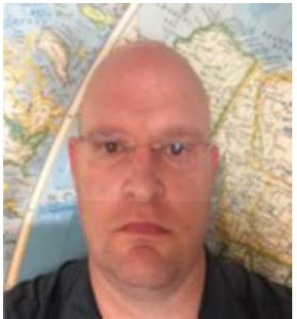

***Jacob Cluver*** *Owner/CEO* [*jacob@agwic.com*](mailto:jacob@agwic.com)



### Bechtel

Bechtel is one ofthe most respected global engineering, construction, and project management companies. Together with our customers, we deliver landmark projects that create long-term progress and economic growth.

While our expertise ensures delivery, ongoing collaboration is critical to long-term success. By aligning our capabilities to our customer's goals, we help them create industry and economies; improve access to energy and resources; connect citizens to vital services; and make the world a safer and cleaner place.

Since 1898, we have been the trusted partner of industry and governments worldwide, helping them deliver more than 25,000 projects in 160 countries on all seven continents. We serve the Infrastructure; Nuclear, Security & Environmental;Oil,Gas & Chemi­ cals; and Mining & Metals markets. Our services span from initial planning and investment, through start-up and operations.

Core to Bechtel are our values-ethics, safety, quality, people, culture, relationships, innovation and sustainability, and our covenants - integrity, respect, collaboration, trust, and delivery. They are what we believe, what customers can expect, and how we deliver.

### Bechtel

Bechtel RB/lReTcR OAHOH H3 caMblX yBa>KaeMblX rno6a/lbHblX KOMnaHHH B 0611acrn npoeKTHpOBaHHfl, CTpOHTe/lbCTBa H ynpaB/leHHfl npoeKTaMH. BMeCTe c HaWHMH K/lHeHTaMH Mbl ocyw,ecTB/lfleM KpynHble cTpOHTe/lbHble npoeKTbl, o6ecne4HBaiow,11e AOllrocpo4HblH nporpecc H 3KOHOMH4eCKHH pocT.

B TO BpeMR KaK Haw onblT rapaHrnpyeT AOCTH>KeHHe pe3y11bTaTOB, nocTORHHOe COTPYAHH4eCTBO HMeeT

pewaiow,ee 3Ha4eHHe *AJl R* o6ecne4eHHR A011rocpo4HOro

ycnexa. ConocTaB11RR Haw11 B03MO>KHOCTH c u,e11RMH HaWHX K/lHeHTOB, Mbl noMoraeM HM B C03AaHHH npoMb1w11eHHOCTH 11 pa3BHTHH 3KOHOMHKH; y11y4weHHH

AOcryna K 3HeprHH H HHblM pecypcaM; nOAK/ll04eHHH rpa>KAaH K >KH3HeHHO Ba>KHblM yc11yraM; H B nocrpoeHHH 6e3onaCHOro H 3K0/10rH4eCKH 4HCTOro MHpa.

c 1898 rDAa Mbl flB/lfleMCfl HaAe>KHblM napTHepoM AJlfl npOMblW/leHHblX npeAnpHRTHH H npaBHTe/lbCTB BO BCeM MHpe, COAeHCTBYR pea/lH3aU,HH 6011ee 25 000 npoeKTOB B 160 crpaHax Ha Bcex ceMH KOHTHHeHTax. Mbl pa6oTaeM B

TaKHX OTpaCllflX KaK pa3BHTHe HH<l>paCTPYKTYPbl ,RAepHafl 3HeprernKa, 6e3onacHOCTb H 3KO/lOrHR, Hecl>Tera3oBaR, XHMH4eCKafl, H ropHO-MeTa1111yprH4eCKafl. HawH yC/lyrH noKpblBalOT nepBOHa4a/lbHOe n11aHHpOBaHHe, HHBeCTHU,HH, 3anycK, H 3KCn11yaTaU,HIO.

OcHOBOH Bechtel RBllRIOTCR Haw11 u,eHHocrn: arnKa, 6e3onacHOCTb, Ka4eCTBO, lllOAH, KYllbTYpa, OTHOWeHHfl, HHHOBaU,HH H ycTOH4HBOCTb, a TaK>Ke HaWH npHHU,Hnbl: 4eCTHOCTb, yBa>KeHHe, COTPYAHH4eCTBO, AOBep11e H CBOeBpeMeHHOCTb AOCTaBKH pe3yllbTaTOB. 3TO TO, BO 4TO

Mbl BepHM, 4ero MOrYT O>KHAaTb K/lHeHTbl,H KaK Mbl YAOB/leTBOpReM HX O>KHAaHHR.

*Entela Ruci*

*Regional Country Manager* [*eruci@bechtel.com*](mailto:eruci@bechtel.com)

Bell Helicopter Textron Inc.

Above and Beyond Flight

**f:J:t!!**

## Bell Helicopter Textron Inc.

•

Bb1we VI AallbWe no11eTa

We are pioneers. We were the first to break the sound barrier and to certify a commercial helicopter. We were aboard NASA's first lunar mission and brought advanced tiltrotor systems to the market. Today,

we're defining the future of on-demand mobility and vertical lift.

For decades, Bell has made its name known by build­ ing aircraft that saves lives. Rapidly delivering and retrieving warfighters in extreme, challenging environ­ ments. We've been developing agile machinery built for fast transport and swift movement for a while.

But creating the next-generation of vertical lift prod­ ucts means thinking above and beyond flight. When it comes to developing the world's first air taxi or pro­ ducing life-saving commercial and military aircraft, we have the innovative minds and the relentless drive to revolutionize search and rescue operations, business travel and vertical takeoff and lift. And we are just getting started.,R22, R44 and soon R66 helicopters under our Apollo Spray division.

Mb1 nV10Hepb1. Mb1 nep8blMVI npe0Ao11e11V1 38YK080M 6apbep VI ceprncl>V1u,V1po8a11V1 KOMMepYeCKVIM 8epT011eT. Mbl 6b111V1 Ha 6opTY nep80M 11yHHOM MVICCVIVI HACA VI

npeACTa8Vl/IVI Ha pblHKe nepeA08ble CVICTeMbl KOH8epTOn/laH08. CeroAHR Mbl onpeAe/IReM 6yAyw,ee onepaTV18HOM M06VlllbHOCTVI VI 8epTVIKa/lbHOro 83/leTa.

B TeYeHVle MHornx AeCRTV111eTV1M 6e1111 Ae11a11 C8oe VIMR y3Ha8aeMblM C03Aa8aR caM011eTb1, KOTOpb1e cnacaioT

>KVl3HVI. oblCTpaR AOCTa8Ka VI noVICK 80eHHblX 8 3KCTpeMa/lbHblX VI c11o>KHb1x yC/I08VIRX. Mb1 yme Aa8HO pa3pa6aTbl8aeM rn6Kyl0 TeXHVIKy, C03AaHHYIO AJIR 6blCTPOM TpaHcnopTV1p08KVI VI onepaTVl8HOro nepeA8Vl>KeHVIR.

Ho C03AaHV1e Vl3Ae11VIM c 8epTV1KaJ1bHblM 83/leToM c11eAyiow,ero noK011eHV1R 03HaYaeT AYMaTb He TOllbKO o no11eTe, HO VI o 6yAyW,eM. KorAa Ae110 AOXOAVIT AO

pa3pa60TKVI nep8oro 8 MVlpe 803AYWHOro TaKCVI Vl/IVI npOV1380ACT8a cnacaTe/lbHblX KOMMepYeCKVIX VI 80eHHblX caMO/leT08, y Hae eCTb VIHH08aU,VIOHHble 83rllRAbl VI HeycraHHOe CTpeM/leHVle pe80lllOU,VIOHVl3Vlp08aTb noV1CK08b1e VI cnacaTellbHble onepaLJ,VIVI, Ae1108b1e noe3AKVI, 8epTV1Ka/lbHblM 83/leT VI nOAbeM. Mbl TO/lbKO HaYVIHaeM.,npOV1380Aff 8epT011eTb1 R22, R44 VI cKopo R66 8 HaweM noApa3Ae11eHV1V1 Apollo Spray.

*Sergey Filatov*

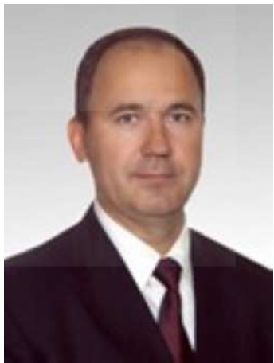

*Regional Sales M anager* [*sfi/atov@bellflight.com*](mailto:sfi/atov@bellflight.com)

 

**Educational Testing Service (ETS) Global**

ETS is the world's largest private, nonprofit education and workforce assessment organization with a mission to help advance quality and equity in education by providing fair and valid assessments, research and related services. ETS designs, administers and scores more than 50 million tests annually in more than 180 countries. ETS products measure knowledge and

skills, promote learning and performance, and support education and professional development for all people worldwide. ETS conducts educational research, analy­ sis and policy studies to inform education policy and serves in advisory roles to governments around the world in developing or improving assessment tools to increase the quality and reputation of their education­ al institutions and programs. ETS is also very well­ known for the TOEFL® and TOEIC® assessment pro­ grams, which measure English proficiency skills. In addition, ETS's GRE® test is the world's most widely administered graduate-level admissions test used by graduate, business and some law schools throughout the world.

Through its subsidiary, ETS Global,ETS serves 80 coun­ tries across Europe, South America, Asia, the Middle East and Africa and bringing expertise to educational and business communities, including domestic and multinational companies, language schools, academic institutions, and government organizations. It offers a wide range of ETS products, such as English and

French language assessments, as well as customized learning solutions and preparation tools for non-native language speakers.

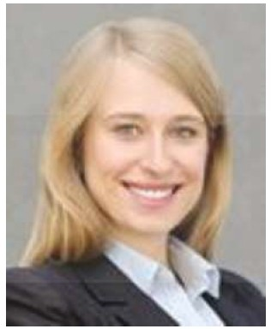

***Anna Gutkawska-Zajac*** *Regional Senior Manager ETS Global* [*agutkowska@etsglobal.org*](mailto:agutkowska@etsglobal.org)

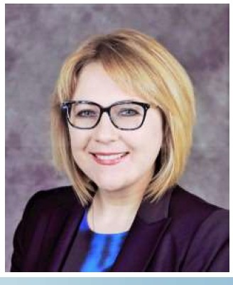

***Patina Levit***

*Director*

*Globa/1 Government* & *External Relations, ETS* [*psavina-levit@ets.org*](mailto:psavina-levit@ets.org)

**Educational Testing Service (ETS) Global**

ETS ffBm1eTCff KpynHei1wei1 B MMpe 4aCTHOH HeKOMMep4eCKOH opraHM3aU,MeH no o6pa30BaHMIO M ou,eHKe pa6o4eH cMnb1, 3aAa4eH KOTopoi1 ffBnff eTCff COAeHCTBMe nOBblWeHMIO Ka4eCTBa M paBHOnpaBMff B o6pa30BaHMM nYTeM npeAOCTaBneHMff cnpaBeMMBblX M AOCTOBepHblX ou,eHOK, MccneAOBaHMH M COnYTCTBYIOW,MX

ycnyr. E>1<eroAHO ETS pa3pa6aTblBaeT, aAMMHMCTpMpyeT M ou,eHMBaeT *6onee* 50 MMnnMOHOB TeCTOB B *6onee* 4eM 180 CTpaHax. npOAYKTbl ETS no3BOnff lOT M3MepffTb ypoBeHb 3HaHMH M HaBblKOB, cnoco6CTBYIOT o6y4eHMIO M ycneBaeMOCTM, M noMep>KMBalOT AOCTYnHOCTb o6pa3oBaHMff M npoct>eccMoHanbHoro pa3BMTMff Anff Bcex

nioAeH BO BCeM MMpe. B o6nacTM o6pa3oBaHMff ETS npOBOAMT MCtneAOBaHMff, aHanM3 M M3y4eHMff npOBOAMMblX nonMTMK, 4T06bl BbltrynaTb

KOHCynbTaHTaMM npaBMTenbCTB B pa3HblX crpaHax MMpa B Bonpocax pa3pa60TKM MnM yny4weHMff ou,eH04HblX MHCTpyMeHTOB, nOBblWeHMff Ka4eCTBa M penYTaU,MM MX y4e6Hb1x 3aBeAeHMH M nporpaMM. ETS TaK>Ke 04eHb M3BecreH CBOMMM nporpaMMaMM ou,eHKM TOEFL® M TOEIC®, KOTOpb1e M3MepRIOT ypoBeHb BnaAeHMff aHrnMHCKMM ff3blKOM. KpoMe Toro, TeCT ETS GRE®

ffBnff eTCff HaM6onee WMPOKO npMMeHff eMblM B MMpe TeCTOM Anff nOCTYnneHMff, MCnOnb3yeMblM BblnYCKHMKaMM, 6M3HeC-WKOnaMM M HeKOTOpblMM IOPMAM4eCKMMM WKOnaMM BO BCeM MMpe.

llepe3 CBOIO A04epHIOIO KOMnaHMIO ETS Global,ETS o6cny>KMBaeT 80 crpaH B EBpone, IO>KHOH AMepMKe,

A3MM, linM>KHeM BocroKe M Acl>pMKe, a TaK>Ke

npeAOCTaBnff eT 3KCnepTHble 3HaHMff o6pa30BaTenbHblM M 6M3Hec-coo6w,ecTBaM ,BKnl04aff MeCTHb1e M MHOroHaU,MOHanbHble KOMnaHMM, ff3blKOBble WKOnbl, aKaAeMM4eCKMe y4pe>KAeHMff M npaBMTenbCTBeHHble opraHM3aU,MM. KoMnaHMff npeMaraeT wMpOKMH cneKTp npOAYKTOB ETS, TaKMX KaK ou,eHKM no aHrnMHCKOMY M

ct>paHU,Y3CKOMY ff3blKaM,a TaK>Ke MHAMBMAyanbHble peweHMff Anff o6y4eHMff M nOAroTOBKM nMU,, He BnaAelOw,Mx POAHblM ff3blKOM.

**FREEPORT- MCMORA**



# Freeport McMoRan Exploration Company

Freeport-McMoRan Inc. (NYSE: FCX) is the world's largest non-state-owned producer of copper and molybdenum, and a significant producer of gold and by-product cobalt. Freeport operates 11mines in the

Americas and Indonesia, which produce approximately 1.5-2 million metric tons of copper metal per year.

Freeport-McMoRan Exploration Corporation (FMEC) is the exploration wing of Freeport-McMoRan, currently exploring on all inhabited continents. For new mine developments, FMEC in general seeks deposits of at least 3-5 million tons of contained copper metal (or: deposits producing approximately 200,000 tons of copper metal per year for at least 15 years of mine life).

***Michael Huehne*** *Business Manager Exploration* [*mhuehne@fmi.com*](mailto:mhuehne@fmi.com)

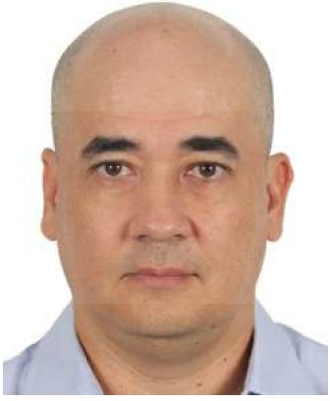

# Freeport McMoRan Exploration Company

Freeport-McMoRan Inc. (NYSE: FCX) RBJIReTCR KpynHeHW VIM B MVlpe HerocyAapCTBeHHblM npOV13BOAVITe/leM MeAVI VI MOJIVl6AeHa, a TaK>Ke 3Ha4VITe/lbHblM npOV13BOAVITe/leM 30/IOTa VI K06aJlbTa B

Ka4eCTBe no6o4HOro npOAYKTa. Freeport ynpas11ReT 11

PYAHV1KaMV1 B CesepHOH VI IO>t<HOH AMepV1Ke VI

lllHAOHe3VIVI, KOTOpble npOV13BOART npV16JIVl3VITe/lbHO 1,5 -

2 MVIJIJIVIOHa MeTpV14eCKVIX TOHH MeTa/IJIVl4eCKOro MeAVI B

roA.

Freeport-McMoRan Exploration Corporation (FMEC) RBJIReTCR reo11oropa3BeA04HblM Kpbl/IOM Freeport­ McMoRan, KOTOpoe B HaCTOR w,ee BpeMR BeAeT

Vl3blCKaHVIR Ha scex Hace11eHHblX KOHTVIHeHTax. *All R*

pa3pa6oTKVI HOBblX PYAHVIKOB, B u,e110M FMEC VIW,eT MeCTOPO>t<AeHVIR, COAep>1<aw,V1e He MeHee 3-5 MVIJIJIVIOHOB TOHH MeTa/IJIVl4eCKOH MeAVI (VlllVI MeCTOpO>t<AeHVIR, npOV13BOAR W,Vle npVIMepHO 200000 TOHH MeTa/IJIVl4eCKOH

MeAVI B roA B Te4eHV1e He MeHee 15 11eT cpoKa c11y>1<6b1 waxTbl).

*Matej Kenda*

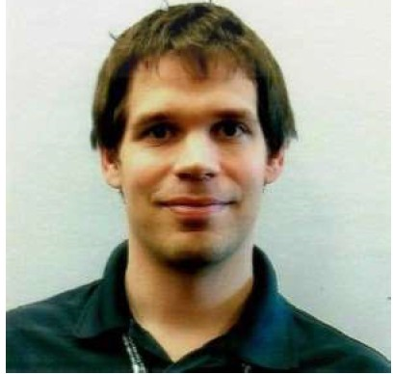

*Community* & *Government Relations Manager Exploration* [*mkenda@fmi.com*](mailto:mkenda@fmi.com)

GE Transportation

•

a Wabtec company

GE Transportation a Wabtec Company

GE Transportation a Wabtec Company combines decades of industrial leadership with cutting-edge data science and analytics acumen to create an

efficient, productive and reliable digital-rail ecosystem

- from shipper to receiver - from ports to intermodal terminals - main line locomotives and railcars - to train yards and operation centers.

We are a leader in freight solutions for the rail industry. This includes a compelling and comprehensive line of locomotives, including the most efficient diesel-electric fleet in the world, and a broad selection of mission-critical controls, including Positive Train Control (PTC), cabin, and advanced braking systems. We meet the total lifecycle needs of the entire fleet: from new locomotives, to modernizations, service and repairs. We add value at every point to help customers realize the most value from their Investment.

*Pavel Semikopenko Regional Service Executive*

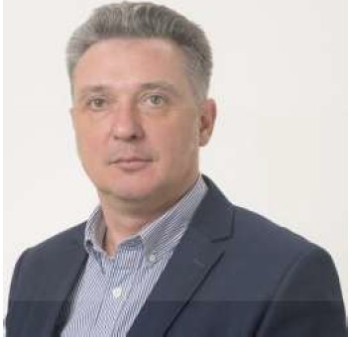

[*Pavel.semikopenko@ge.co*](mailto:Pavel.semikopenko@ge.co) *m*

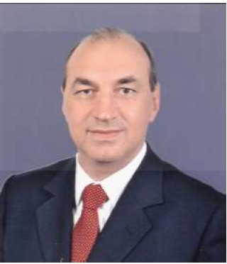

GE Transportation a Wabtec Company

GE Transportation a Wabtec Company Rem:1eTcR KOM6V1HaU,V1eH AeCRTVlneTVIH npOMblWneHHOro nVIAepCTBa c nepeAOBblMVI TexHonorviRMVI o6pa6oTKVI AaHHblX VI aHanVITHKVI e Aene C03AaHlllR 3cl>cl>eKTlllBHOH, npOAYKTVIBHOH VI HaAe>KHOH 3KOCVICTeMbl U,Vlcl>POBblX

>Kene3HOAOPO>KHblX nepeB030K OT rpy3oompae111TenR AO nony4aTenR, OT nopTOB AO VIHTepMOAanbHblX TepMlllHanoe, MarHCTpanbHblX nOKOMOTlllBOB "'

>Kene3HOAOPO>KHblX earoHOB, >Kene3HOAOPO>KHblX CTaHU,VIH VI onepaU,VIOHHblX u,eHTPOB.

Mbl RBnReMcR nVIAepoM e o6nacrn peweHVIH nepeeo3Klll rpy30B *AnR* >Kene3HOAOPO>KHOH OTpacn111. 3TO BKnl04aeT B ce6R c111nbHY10 111 eceoxeaTb1eaiow,yio nVIHeHKY noKOMOTVIBOB, B TOM 4Vlcne caMblH 3cl>cl>eKTVIBHblH A1113enb- 3neKTpV14eCKlllH napK B Mlllpe, WlllpOKlllH Bb16op KpVITVl4eCKlll Ba>KHblX 3neMeHTOB ynpaeneHlllR, BKnl04aR ClllCTeMy ynpaeneHlllR noe3AOM (PTC), Ka6111Hbl "' coepeMeHHble TOpM03Hble ClllCTeMbl. Mbl OTBe4aeM 3a ece noTpe6HOCTVI >Kl-13HeHHOro U,lllKna ecero napKa: OT HOBblX noKoMorneoe AO MOAepH1113au,111111, 06cny>1<111eaHV1R 111 peMOHTa. Mbl BKnaAblBaeM A06aB04HYIO CTOlllMOCTb B Ka>KAblH 3neMeHT, 4T06b1 noM04b Kn111eHTaM nony4111Tb MaKClllManbHYIO OTAa4y OT CBOVIX lllHBeCTVIU,VIH.

*Asli Ozkan*

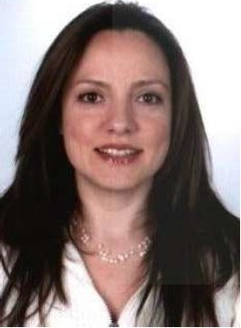

*Regional Marketing Leader* [*asli.ozkan@ge.com*](mailto:asli.ozkan@ge.com)

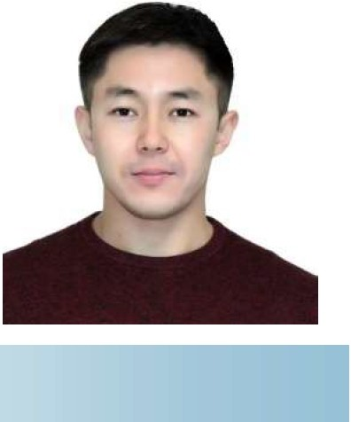

*Sinon Haseki*

*Senior Sales Manger* [*ainan.haseki@ge.com*](mailto:ainan.haseki@ge.com)

*Baurzhan Jumanov*

*Regional Project Manager* [*baurzhan.jumanov@ge.com*](mailto:baurzhan.jumanov@ge.com)

**John Deere**

**JOHN DEERE**

**John Deere**



John Deere (Deere & Company - NYSE: DE) is a world leader in providing advanced equipment and service and is committed to the success of customers whose work is linked to the land - those who cultivate, harvest, transform, enrich, and build upon the land to meet the world's dramatically increasing need for food, fuel,shelter, and infrastructure. John Deere also provides financial services worldwide and manufactures and markets engines used in heavy equipment. Since it was founded in 1837, the

company has extended its heritage of integrity, quality, commitment and innovation around the globe. Headquartered in Moline, Illinois, John Deere employs more than 73,000 people worldwide.

John Deere is committed to serving as a strategic partner in support ofthe agricultural sector in Uzbekistan through innovative solutions to meet the needs of Uzbek farmers as well as support for

technical training and education. John Deere has been represented in Uzbekistan by Landtech LLC, part of the CIS Equipment Group, since 2007.

John Deere (Deere & Company - NYSE: DE) RB/lReTcR M11pOBblM 1111AepoM B 0611acT11 nocraBOK nepeAOBOro 06opyA0BaH11R 11 yc11yr. KoMnaH11R Hau,e11eHa Ha 06ecneL1eH11e ycnexa cso11x n0Tpe611Te11ei.1, 4bfl pa6oTa CBR3aHHa c 3eM/leM, Tex KTO 3aHl1MaeTCfl KYllbT11s11posaH11eM, B03Ae11b1BaH11eM,TpaHcct>opMau,11ei.1, 06oraw,eH11eM 11 pa3Bl1Tl1eM 3eMe/lbHblX HaAe11os c u,e11b10 YAOB11eTsopeH11R pe3KO B03pocwei.1 noTpe6HocT11 B npOAOBO/lbCTBl111, TOn1111se, Kpose 11 11Hct>paCTPYKTYpe. KpoMe 3Toro, John Deere npeAOCTaB11ReT ct>11HaHcosb1e

yc11yr11 no BCeMy M11py, a TaK>Ke np0113BOA11T 11 npOAaeT

ABl1raTe1111. c MOMeHTa csoero OCHOBaHl1fl B 1837 roAy, KOMnaHl1fl pacw11p1111a CBOe HaC/leA11e u,e110CTHOCT11, Ka4eCTBa, OTBeTCTBeHHOCTl1 11 11HHOBaU,11M no BCeMy M11py.

WTaTa KOMnaH1111 John Deere co wTa6-Ksaprnpoi.1 B ropoAe Mo1111He, wTaT 111111Hoi.1c, HaC411Tb1saeT 6011ee 73 Tb1Cfl4 4e/lOBeK no BCeMy M11py.

John Deere o6R3a11ocb 6b1Tb cTpaTer114ecK11M napTHepoM Y36eK11cTaHa B 0611acT11 noAAep>1<K11 ce11bCKoro xo3RMCTBa CTpaHbl nYTeM npeAOCTaB/leHl1fl 11HOBaU,110HHblX peweHl1M B sonpoax YAOB11eTsopeH11R noTpe6HocTei.1 ct>epMepos 11 noAAep>t<Kl1 TexH11L1ecKoro 06yL1eH11R 11 06pa3osaH11R. B Y36eK11cTaHe John Deere npeACTas11eH KOMnaH11ei.1 Landtech LLC, c 2007 roAa BXOAR W,eM B CIS Equipment Group.

***Nikolay Orlenko***

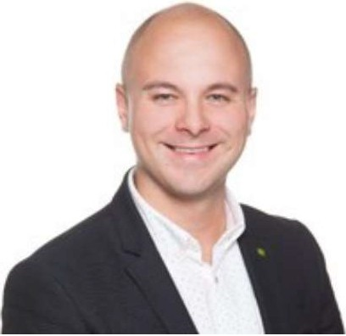

*Territory Manager* [*orlenkonikolay@JohnDeere.com*](mailto:orlenkonikolay@JohnDeere.com)

**Medtronic**

**Medtronic**

Medtronic, founded in 1949, is among the world's largest medical technology, services, and solutions companies - alleviating pain, restoring health, and extending life for millions of people around the world. Our primary customers include hospitals, clinics,

third-party health care providers, distributors, and other institutions, including governmental health care programs and group purchasing organizations (GPOs) in more than 150 countries worldwide. We have four operating and reportable segments that primarily develop, manufacture, distribute, and sell

device-based medical therapies and services - Cardiac and Vascular Group, Minimally Invasive Therapies Group, Restorative Therapies Group, Diabetes Group.

Our Mission, written in 1960, dictates that our first and foremost priority is to contribute to human

welfare. Over a half-century later, it continues to serve as our ethical framework and inspirational goal for our employees around the world. It guides our day-to-day work and reminds us that our efforts are transforming the lives of millions of people each year.

#### Medtronic

OcHoeaHHaR e 1949 roAy, Medtronic BXOA"1T e 41-1c110 KpynHeHW"1X B Mi.1pe KOMnaH"1H, 3aH"1MalOW,"1XCR

TexH011orn RM"1,yc11yraM1-1 1-1 peweH"1RM"1 e 0611acrn MeA"1U,"1HCK"1X TeXH0/10r"1H, 0611erYaR 6011b,

BOCCTaHaB/1"1BaR 3AOPOBbe "1 npOA/leBaR >K"13Hb M"1/l/1"10HaM lllOAeH BO BCeM Mi.1pe. HaW"1M"1 OCHOBHblMl-1 K/1"1eHTaM"1 R B/lRIOTCR 60JlbH"1U,bl ,K/1"1H"1K"1,nocTaBW,"1K"1

MeA1-1u,1-1HcK1-1x yC11yr, A"1CTp1-16b10Topb1 1-1 Apyrne

yype>KAeH1-1R, e TOM Y1-1C11e rocyAapcreeHHble nporpaMMbl 3ApaeooxpaHeH"1R 1-1 opraH1-13au,1-11-1 rpynnoBblX 3aKynoK (GPO) B 6011ee YeM 150 CTpaHax Mi.1pa. y Hae eCTb YeTblpe onepaU,"10HHblX "1 OTYeTHblX cerMeHTa, KOTOpble B nepBylO oYepeAb pa3pa6aTb1Ba10T,npo1-13BOAffT, pacnpocrpaHRIOT "1 npOAalOT MeA"1U,"1HCK"1e cpeACTBa "1 yC/lyrn Ha OCHOBe ycTpOHCTB AJlff rpynn cepAeYHO-COCYA"1CTOH C"1CTeMbl, rpynn M"1H"1Ma/lbHO "1HBa3"1BHOH Tepan1-11-1, rpynn BOCCTaHOB"1Te/lbHOH Tepan1-11-1, "1 rpynn A"1a6eTa.

Hawa M"1CC"1R, Han1-1caHHaR B 1960 roAy, rnaC"1T, 4TO Hawa nepeooYepeAHaR 3aAaYa - cnoco6cTBOBaTb 611arococTORH"110 lllOAeH. CnycTR no11eeKa oHa npOAO/l>KaeT CllY>K"1Tb HaweH 3T"14eCKOH OCHOBOH "1 BAOXHOB/lRIOW,eH u,e11b10 AJlR Haw1-1x COTPYAH"1KOB no

eceMy M1-1py. 0Ha pyKoBOA"1T HaweH noeceAHeBHOH pa60TOH "1 HanOM"1HaeT HaM 0 TOM, 4TO HaWl-1 YC"1/1"1R

Ka>KAblH rDA npeo6pa3ylOT >K"13H"1 M"1/l/1"10HOB lllOAeH.

*Nataliya Varich*

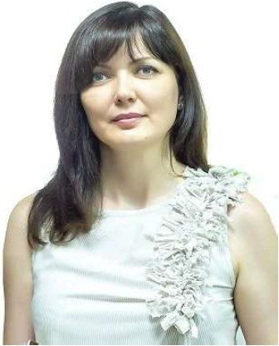

*Country Director*

*Central Asia1 Armenia* & *Georgia nataliya.* [*varich@medtronic.com*](mailto:varich@medtronic.com)

**m1yamoto.**

we save lives and impact communities

#### Miyamoto International

Founded in 1946 in Sacramento, California, Miyamoto International is a global earthquake + structural engi­ neering firm. The firm specializes in High Performance Earthquake Engineering solutions that reduce life­ cycle costs and realize a positive net impact on a struc­ ture's operation.

We provide the highest quality engineering expertise for some of the most challenging projects in the world throughout the Americas, Asia, and Europe. Our cli­ ents include governments, private sector organiza­ tions, developers, architects and contractors who desire highly effective and sustainable technical solu­ tions.

We have specific experience in seismic design and high

-performance earthquake engineering with the high­ est level of expertise and training in high seismic risk areas such as California, Japan and Turkey. Miyamoto offices are strategically located worldwide in earth­ quake-hazard regions to positively impact economies.

#### Miyamoto International

06pa30BaHHaR B 1946 rOAY B KaJJ111<1>opHHHCKOM ropOAe

CaKpaMeHTO, Miyamoto International RB/lReTcR rno6a11bHOH <l>HPMOH no npoeKrnposaHHIO CTPYKTYP nosb1weHHOH ceHCMH4eCKOH ycroH4HBocrn. <l>HpMa cneu,Ha/lH3HpyeTCR Ha BblCOK03<l><l>eKTHBHblX HH>KeHepHblX peweHHRX ceHCMH4eCKH ycTOH4HBblX KOHCTPYKU,HH, CHH>KalOW,HX ce6eCTOHMOCTb >KH3HeHHOro U,HK/la H

OKa3blBalOW,HX no3HTHBHOe B/lHRHHe Ha 3KCn11yaTaU,HIO TaKHx CTPYKTYP·

Mb1 npeAOCTaB11ReM HH>KeHepHble KOHCYllbTaU,HH BblC04aHwero Ka4eCTBa no HeKOTOpblM C/lO>KHeHWHM B MHpe npoeKTaM OT CesepHOH H IO>t<HOH AMepHKH AO A3HH H Esponb1. HawHMH 3aKa34HKaMH RB/lRIOTCR npaBHTe/lbCTBa, opraHH3aU,HH 4aCTHOro ceKTOpa, pa3pa60T4HKH, apxHTeKTOpbl H nOAPRA4HKH, HW,YW,He

BblCOK03<l><l>eKTHBHble H ycTOH4HBble TeXHH4eCKHe peweHHR.

Mbl 0611aAaeM KOHKpeTHblM onblTOM B ceHCMH4eCKOM npoeKrnpoBaHHH H pa3pa60TKe BblCOK03<l><l>eKTHBHblX ceHCMH4eCKH ycTOH4HBblX KOHCTPYKU,HH, BblC04aHWHM ypoBHeM 3HaHHH H nOArQTOBKH B 0611aCTRX c BblCOKHM ceHCMH4eCKHM pHCKOM,TaKHx KaK Ka11Hcl>opHHR, RnoHHR

H Typu,HR. O<l>Hcb1 Miyamoto crpaTern4eCKH

pacno110>1<eHb1 no sceMy MHPY B pernoHax c noBb1weHHOH ceHCMH4eCKOH aKTHBHOCTblO, 4T06bl OKa3blBaTb nO/lO>KHTe/lbHOe B/lHRHHe Ha 3KOHOMHKY B TaKHX CTpaHax.

***Yusuf Zahit Gundogdu***

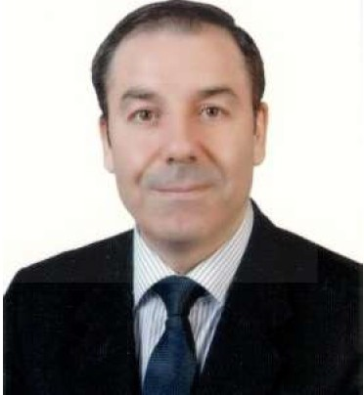

*President*

*Miyamoto International Turkey* [*yzahit@miyamotointernational.com*](mailto:yzahit@miyamotointernational.com)

***&G***

**Procter & Gamble**

P&G (Procter & Gamble) ,founded over 180 years ago, today, is the world's largest consumer goods company and home to iconic, trusted brands that make life a little bit easier in small but meaningful ways. We've spanned three centuries thanks to three simple ideas: leadership, innovation and citizenship. P&G serves consumers around the world with one of the strongest portfolios oftrusted, quality, leadership brands, in­ cluding Always®, Ambi Pur®, Ariel®, Bounty®, Char­ min®, Crest®, Dawn®, Downy®, Fairy®, Febreze®,

Gain®, Gillette®, Head & Shoulders®, Lenor®, Olay®, Oral-B®, Pampers®, Pantene®, SK-II®, Tide®, Vicks®, and Whisper®. The P&G community includes opera­ tions in approximately 70 countries worldwide.

***Tankut Turnaoglu***

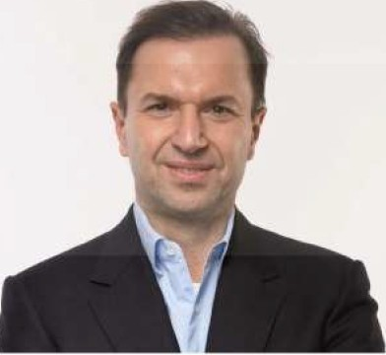

*CEO, P&G Turkey, Caucasus and Central Asia Republics* [*turnaoglu.*](mailto:turnaoglu.t@pg.com)[*t@pg.com*](mailto:t@pg.com)

**Proctor & Gamble**

OcHoeaHHaR *6onee* 180 neT Ha3aA, KoMnaHVIR P&G ceroAHR RBnReTCR KpynHeHW VIM B MVlpe npOV13BOAVITeneM noTpe6V1TenbCKVIX TOBapoe VI AOMOM *M R* 3HaKOBblX VI 3acny>K VIBW VIX AOBepVle 6peHAOB, KOTOpble B 3Ha4VITenbHOH Mepe o6ner4alOT >KVl3Hb. Mbl OXBaTVlnVI TpVI CToneTVIR 6naroAapR TpeM npOCTblM VIAeRM: nVIAepCTBO, VIHHOBaU,VIVI VI COU,VlanbHaR OTBeTCTBeHHOCTb. P&G cny>KVIT

noTpe6V1TenRM no eceMy MVIPY c OAHVIM Vl3 caMblX MOW,HblX Ha6opoe HaAe>KHblX, Ka4eCTBeHHblX, VI nVIAVIPYIOW,VIX 6peHAOB, TaKVIX KaK Always®, Ambi Pur®, Ariel®, Bounty®, Charmin®, Crest®, Dawn®, Downy®, Fairy®, Febreze, Febreze ®,Gain®, Gillette®, Head & Shoul­ ders®, Lenor®, Olay®, Oral-B®, Pampers®, Pantene®, SK- 11®, Tide®, Vicks® VI Whisper®. Coo6w,ecreo P&G pa6oTaeT npVIMepHO B 70 CTpaHax MVlpa.

***Deger Kurtaslanoglu***

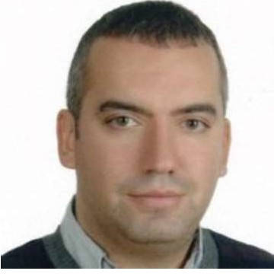

*Country Director, P&G Turkey, Caucasus and Central Asia Republics* [*Kurtaslanoglu.d@pg.com*](mailto:Kurtaslanoglu.d@pg.com)



Silverleafe International Silverleafe International

*Dan Patterson Martin Walker*

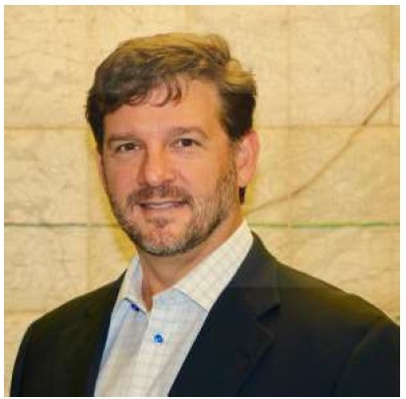

*President Vice President of Agriculture*

[*d.patterson@silverleafe.com*](mailto:d.patterson@silverleafe.com)[*m.walker@silverleafe.com*](mailto:m.walker@silverleafe.com)



·

<Ueechcraft ***j§owker.***

Cessna

#### Textron Aviation

**TEXTRON VIATION**

#### Textron Aviation

Textron Aviation Inc. is the leading general aviation authority and home to the Beechcraft, Cessna and Hawker brands which account for more than half of all flying general aviation

aircraft.

Products include best-selling aircraft such as:

0 Citation business jets

0 King Air and Caravan turboprops

0 Cessna and Beechcraft pistons

* 19 aircraft in production
* Over 250,000 aircraft delivered in 90 years
* Combined fleet exceeding 150 million flight hours
* Announced, certified and delivered 10 products in last 6 years
* More than 12,000 employees worldwide
* 18 company-owned service centers

Textron Aviation Inc. is the leading general aviation au­ thority and home to the Beechcraft, Cessna and Hawker brands which account for more than half of all flying gen­ eral aviation

aircraft.

Products include best-selling aircraft such as:

0 Citation business jets

0 King Air and Caravan turboprops

0 Cessna and Beechcraft pistons

* 19 aircraft in production
* Over 250,000 aircraft delivered in 90 years
* Combined fleet exceeding 150 million flight hours
* Announced, certified and delivered 10 products in last 6 years
* More than 12,000 employees worldwide
* 18 company-owned service centers

***Alexey Sigalaev*** *Regional Sales Director* [*asigalaev@textav.com*](mailto:asigalaev@textav.com)

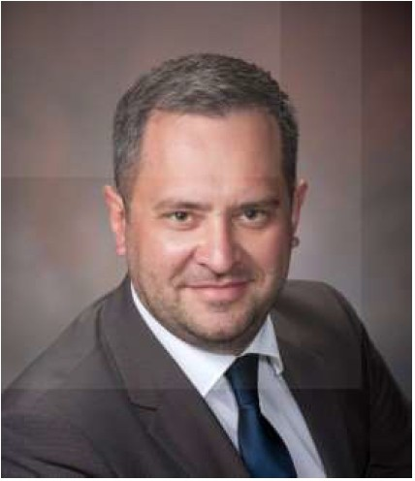



# Zeppelin CAT

Heavy equipment manufacturer Caterpillar sells its products around the world through its unique dealer network, guaranteeing the continuous supply of consumables, spare parts, and highly skilled service technicians onsite. This translates to exceptional performance and maximum operating time for our customers. Whether paving roads, mining essential commodities or extracting the fuels to satisfy global energy demand, we provide the solutions that help our customers build a better world.

Since 1997, Caterpillar has been sold and serviced in Uzbekistan by Zeppelin International,a subsidiary of the Zeppelin Group, a German corporation with 60+ years as an exclusive Caterpillar dealer in many coun­ tries around the world. Zeppelin has implemented major projects in the construction, mining, and oil and gas industries across the region. With Caterpillar equipment from Zeppelin, projects are completed on time and on budget.

Caterpillar is the world's leading manufacturer of construction and mining equipment, diesel and natural gas engines, industrial gas turbines and diesel-electric locomotives. Our equipment is distinguished by its unsurpassed reliability and performance. It is an investment which provides customers with the lowest cost per ton of material transported, per kilometer of road or tunnel built, and by kilowatt per hour of

energy generated.

***Elena Strok*** *Area Manager Caterpillar*

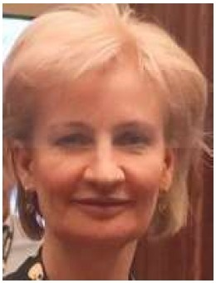

[*strok_elena_i@cat.com*](mailto:strok_elena_i@cat.com)

***Lyna Davydova***

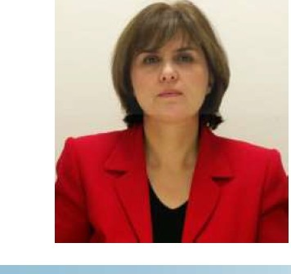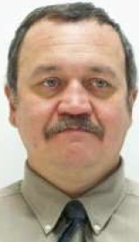

*Sr. Government and Corporate Affairs Representanve Caterpillar*

[*davydova_elina_/@cat.com*](mailto:davydova_elina_/@cat.com)

**Zeppelin CAT**

npo113BOA11Te/lb TI'l>Ke/IOH TeXHl1Kl1 Caterpillar pea11113yeT CBOIO npOAYKU,11IO no BCeMy Ml1PY 4epe3 CBOIO

yH11KaJ1bHY10 A1111epcKyio ceTb, rapaHrnpyiow,yio HenpepblBHYIO nocTaBKY paCXOAHblX MaTep11a110B, 3anaCHblX 4aCTeH 11 BblCOKOKBa1111ct>11u,11poeaHHblX TeXHl1KOB *AJI R* 06c11y>1<11BaHl1ff Ha MeCTe. 3TO 03Ha4aeT

11cK1110411Te11bHYIO npo113BOA11Te11bHOCTb 11 yee11114eH11e AO

MaKCl1MyMa epeMeHl1 npOAYKTli!BHOH pa60Tbl Haw11x K/111eHTOB. EiYAb TO npoKJ1aAKa AOPOr, A06bl4a OCHOBHblX B11AOB CblpbR 111111 TOn1111Ba *AJI R* YAOB/leTBOpeHl1ff

rno6a11bHOro cnpoca Ha 3Heprnio, Mbl npeAJ1araeM peweHl1R, KOTOpble noMoralOT HaWl1M K/111eHTaM nocTp011Tb llY4Wl1H M11p.

C 1997 roAa Caterpillar pea11113yeT 11 06c11y>1<11eaeT ceoio npOAYKU,11IO B Y36eK11cTaHe 4epe3 KOMnaH1110 Zeppelin International,A04epHIOIO KOMnaH1110 HeMeU,KOH KOpnopau,1111 Zeppelin Group, KOTOPOH 6011ee 60 11eT,11 KOTOpaR RB11ReTCR 3KCKlll0311BHblM A1111epoM Caterpillar so MHornx crpaHax M11pa. Zeppelin pea11113oea11a KpynHble npoeKTbl B crpo11Te/lbHOH, ropHOA06b1Ba10w,eH 11

Hect>Tera30BOH OTpaC/IRX no BCeMy pernoHy. c

06opyAOBaH11eM Caterpillar OT Zeppelin, npoeKTbl BblnOllHRIOTCR B cpoK 11 yK11aAblBa10TCR B paMKax 610A>KeTa.

Caterpillar RB11ReTCR BeAYW.11M B M11pe npo113BOA11Te 11eM cTpo11TeJ1bHoro 11 ropHoro 06opyA0BaH11R, A113e/lbHblX 11 ra30BblX AB11raTe11eH, npoMb1w11eHHb1x ra30BblX TYP611H 11 A113e/lb-3/leKTp114ecK11x 110K0Morneoe. Hawe 060PYAOBaH11e OT/1114aeTCR HenpeB30HAeHHOH HaAe>KHOCTblO 11 np0113BOA11Te/lbHOCTblO. 3TO

11Heecrnu,11R, KOTOpaR 06ecne411eaeT K1111eHTaM caMyio Hl13KYIO ce6eCTOl1MOCTb 3a TOHHY TpaHcnopT11pyeMoro MaTep11a11a, 3a K11110MeTp AOporn 111111 nocTpoeHHoro TYHHeJIR, 11 3a Kl1/IOBaTT B 4aC np0113BeAeHHOH 3Heprn11.

***Olim Turayev***

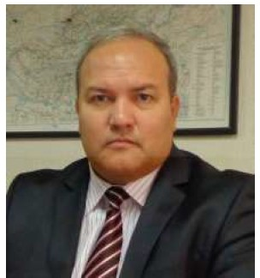

*Head of Representanve Office Zeppelin lnternanonal Uzbekistan* [*olim.turayev@zeppelin.com*](mailto:olim.turayev@zeppelin.com)

***Andrey Shkabardnya*** *CAT Eurasia RR Market Development Manager*

[*--==========--shkabardnia_andrey@cat.com*](mailto:--%3D%3D%3D%3D%3D%3D%3D%3D%3D%3D--shkabardnia_andrey@cat.com)