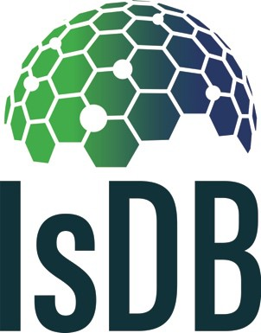

Transformers Roadshow application

Monday 12thMarch 2019

Application form

Application form for the IsDB “Transformers Roadshow” Competition

To take part in the competition, please provide the following information in no more than 500 words in total. Please note deadline for all applications is [26th February 2019 at midnight.]

Name

*Provide name and short description of you project*

……………………………………………………………………………………………………….....

Timeframe

*Provide short description of the timeline of the project*

……………………………………………………………………………………………………….....

……………………………………………………………………………………………………….....

Goals and objectives

*Describe the project objectives in measurable terms that address the supportive agenda of the Sustainable Development Goals (no more than 500 words)*

……………………………………………………………………………………………………….....

……………………………………………………………………………………………………….....

……………………………………………………………………………………………………….....

Sustainability

*Provide brief description on how will you ensure the sustainability of the project (no more than 500 words)*

……………………………………………………………………………………………………….....

……………………………………………………………………………………………………….....

Team

*Include number of staff and core skills represented within the team*

……………………………………………………………………………………………………….....

……………………………………………………………………………………………………….....

……………………………………………………………………………………………………….....

Measurement

*Provide overview of how you will measure the success of your project (no more than 500 words)*

……………………………………………………………………………………………………….....

……………………………………………………………………………………………………….....

……………………………………………………………………………………………………….....

Additional

*Please provide any other information you would like the IsDB team to be aware of when reviewing your application*

……………………………………………………………………………………………………….....

……………………………………………………………………………………………………….....