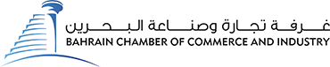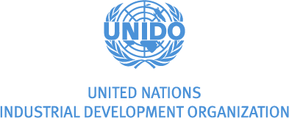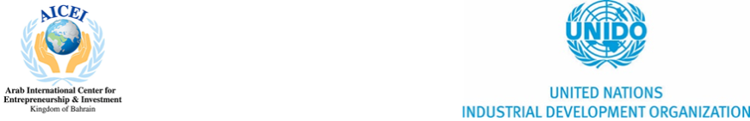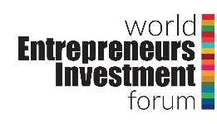

**The Arab Annual Investors Summit**

**The World Entrepreneurs Investment Forum**

**11-13 November 2019, Manama, Bahrain**

**“Achieving the SDGs: Entrepreneurship and Innovation,**

**Investing in the 4th Industrial Revolution in a Digital Economy”**

**Event in Brief**

Under the auspices of His Majesty the King of Bahrain Shaikh Hamad bin Isa Al Khalifa, the 18th Arab Annual Investors Summit and the 3rd edition of World Entrepreneurs Investment Forum 2019 (WEIF 2019) will be held in parallel and run concurrently, both in the Kingdom of Bahrain on the 11th to the 13th of November 2019. The events are organized and supported by the Bahrain Chamber of Commerce & Industry, and the United Nations Industrial Development Organisation (UNIDO ITPO Bahrain), cementing their long-lasting partnership.

The events, both revolving around entrepreneurship and investment, will be themed “Achieving the SDGs through Entrepreneurship & Innovation, Investing in the 4th Industrial Revolution in a Digital Economy”, and will shed light on the Economic Vision 2030 of His Majesty the King of Bahrain. The events will promote and highlight the role of entrepreneurship and innovation towards economic development and achieving the Sustainable Development Goals, while showcasing the significant contribution of the Bahrain Chamber of Commerce & Industry as it celebrates significant successes of its 80th year anniversary.

**Event Premise:**

The events will bring to light the current challenges and opportunities towards sustainable economic development in developing countries, particularly in the MENA region.

**Challenges Faced by the Arab World are Global Concerns –** In the Middle East, a region of some 400 million people, nearly 65 percent of the population is younger than age 30 — the highest proportion of youth to adults in the region’s history. According to the United Nations, developing countries are home to 89 percent of the world’s 10- to 24-year-olds; by 2020, they will be home to nine out of every 10 people globally. The massive youth populations in the region could present the opportunity of the century, or cause very serious global concerns.

The central challenge for the region is to change the trajectory of youth living in difficult circumstances by investing in education, addressing unemployment boosting growth and creating political conditions and economic opportunities to engage its young working-age residents. They need to develop their identities as individuals who have a positive contribution for promising collective future.

If the raised expectations of masses of young people are left unmet, the absence of justice and dignity will foster frustrations, despair, and maltreatment of others. further contributing to social protest, religious radicalization, often in tandem with the rise of secularism. Such social and political instability also contributes to mass immigration fleeing violence, poverty, or simply a lack of opportunity, and also likely to make conditions for women throughout the region worse.

**The Role of Entrepreneurship Towards Addressing Regional Challenges -** The Arab youth will require 100 million jobs by the year 2025. It has been recognized that the answer to employment generation lies in the promotion of the private sector – notably the entrepreneur – through the promotion of investments, both foreign and domestic. The private sector/entrepreneurs are a key partner for economic development, with micro, small, and medium sized enterprises (MSMEs) contributing to high employment rates, poverty reduction, bottom-up economic growth, structural change, and innovation. Entrepreneurship also has a positive role in bridging the technology gap, and provide opportunities for the youth and unemployed to exhibit their potential by being job creators.

However, entrepreneurs require support to facilitate enterprise creation and their sustainability, and the addressal of several challenges: the educational system does not provide the skills required, with difficulty to accessing capital and business development services that are particularly geared to new entrepreneurs. Entrepreneurs tend to be perceived as high-risk, and are often less knowledgeable about networks, markets and investment opportunities and sources of information than older players.

**Education Stimulates the Entrepreneurial Mindset -** Studies indicate that many will benefit from inclusive entrepreneurial education into formal education. Entrepreneurial education plays a key role in transforming entrepreneurial intentions into action, addresses cultural and social beliefs, and further helps increase the regions overall workforce participation by making them more competitive and appealing candidates to employers within the private sector.

Despite a significant improvement in formal education in the Middle East during the past few decades, the gap between education and employment is still widening. Governments across the MENA region have invested heavily in education, yet graduates lack the skills they need to succeed in job markets.

**Women Empowerment through Entrepreneurship & Innovation:** According to the Global Gender Gap report, there is a 39% distance in gender parity for the MENA region, the largest of all regions. Without increasing efforts, it is predicted that it will take 129 years to close the gender gap in the region. This stresses the need for identifying the factors hindering progress and establishing new and more effective ways to overcome them and accelerate gender equality.

Women in the MENA region are generally considered to be a major source of untapped potential. In addition to being well educated, they are reported to have ambitious intentions; 2016 studies reveal that the females in the MENA region have the second highest entrepreneurial intentions, but only few of them translate those intentions into entrepreneurial actions. Promising data reveals that most countries within the MENA region have higher innovation levels among female entrepreneurs, possibly bringing new solutions to the market. They also tend to hire more employees thus create income for themselves, their families and create jobs for others.

According to UN Women, there is a gender gap in innovation and technology- meaning innovation does not benefit women and men on an equal level. Trillions of dollars will continue be lost in the global economy and digital revolution if innovations are not gender responsive.

**The Fourth Industrial Revolution** - As we implement smart technologies in our factories and workplaces, connected machines will interact, visualize the entire production chain and make decisions autonomously. This revolution is expected to impact all disciplines, industries, and economies. The Arab world is at a critical juncture; Ambitious economic and social reforms bring great economic promise to the region and at the same time we continue to see fragility and persisting inequalities that can potentially erode social cohesion. Within a rapidly changing geopolitical landscape, the world is moving from a unipolar system of governance toward a multipolar and multi-conceptual order grounded in competing sets of values and precarious friction points. In this context, much of the hope in the region rests on the imperative of constructing a social contract between the population and the state that is based on a more competitive and open economy, with a dynamic and entrepreneurial private sector offering employment prospects for the region’s youth.

**Event Details:**

The event will comprise of a conference, investors’ exhibition, entrepreneurs’ exhibition, and bilateral meetings. The event will act as a platform for governments, private sector, academia, financial institutions, civil society and entrepreneurs from around the globe to explore possibilities of cooperation, joint investments and business partnerships with potential counterparts.

Event will highlight the challenges faced by the Arab women & youth and the global ramifications, share Bahrain’s successful methodologies related to economic development and entrepreneurship, instigate open dialogue among regulators, experts, entrepreneurs, investors, academia, and others towards tackling challenges and seizing opportunities, allow for bilateral meetings to facilitate partnerships for trade facilitation, technology transfer, and cross border investments.

Speakers in the event will include notable international advocates of social economic development, including high profile individuals from foundations, global companies, relevant associations, and non-governmental organisations.

**Organizers & Event Venue:**

**Representing the Private Sector in the Arab World -** The **Union of Arab Chambers** is an independent non-governmental, non-profit regional legal entity, with an important role in the process of promoting the trade cooperation between the Arab countries at the levels of commerce and investment. The awareness of the Arab Businessmen for the importance of the regional cooperation as a tool to advance the Arab Economic Development was the main motive behind the foundation of this Union so, the Union was the first Arab Economic Institution to work at the non-governmental level in order to promote the idea of economic cooperation and integration among the Arab Countries.

**Kingdom of Bahrain -** As part of the National Reform Programme, **His Majesty King Hamad bin Isa Al Khalifa’s Economic Vision 2030** was launched in October 2008, as a comprehensive economic vision for Bahrain, providing a clear direction for the continued development of the Kingdom’s economy and, at its heart, is a shared goal of building a better life for every Bahraini. The Vision has spearheaded multiple transformational initiatives that lead to economic opportunity and prosperity, which led to awarding His Majesty by UNIDO in Vienna in 2017.

The Kingdom of Bahrain began its partnership with the UNIDO by hosting the **UNIDO’s Investment and Technology Promotion Office** 20 years ago which culminated in the Bahrain Model for entrepreneurship (Enterprise Development & Investment Promotion Program) as developed by UNIDO ITPO Bahrain, delivered through the support of the Arab International Center for Entrepreneurship & Investment.

For the past 80 years, the **Bahrain Chamber of Commerce and Industry (BCCI)** is deemed to be the main representative of the private sector, while contributing significantly to implement the Economic Vision 2030. With its deep-rooted history, it represents the voice of the business and commercial community, encompassing all its various segments and activities. BCCI is the oldest chamber of commerce in the region and has been developing over years in terms of types and sums of services provided, since inception in 1939.