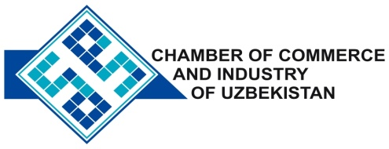

**Commercial offer of Uzbek Products to Foreign Buyer**

Dear Sirs, KP- 002

We are pleased to offer you products of the company JV «Andijankabel»

**Information about the company:**

Company Ltd «Andijankabel" specializes in the production of cable and wire products, commodity wires, twisted wires, mesh fabrics of metals and lubricants.

**List of products:**

Cabling and wiring products

Trading wire, stranded conductor

Woven mesh of metal

Kettles

**Terms of delivery:** FCATashkent

If you are interested, we are happy to provide additional information in accordance with your request.

E-mail: [export@chamber.uz](mailto:export@chamber.uz)

Website: [www.chamber.uz](http://www.chamber.uz)

Export Promotion Department.

Chamber of Commerce of the Republic of Uzbekistan.