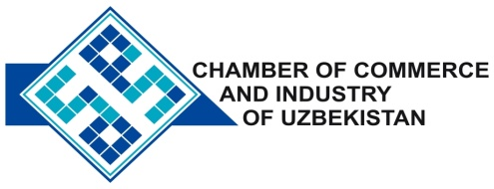

**Commercial offer of Uzbek Products to Foreign Buyer**

Dear Sirs, KP-013

We offer quotation of Uzbek Company Ltd «Stedi».

**Information about the company:**

Company «Stedi» LLC was founded in 2009. The main activity of the company is production of polymeric dyes, additives and modifiers (Master batch), for the manufacture and processing of polymer products. The products are applied to polymers: polyethylene, polystyrene, polypropylene, PVC, ABC and others.

**List of products:**

Polymeric dyes

**Benefits:**

All manufactured products meet the requirements of international standards.

**Terms of delivery:** FCA Tashkent

If you are interested, we are happy to provide additional information in accordance with your request.

E-mail: [export@chamber.uz](mailto:export@chamber.uz)

Website: [www.chamber.uz](http://www.chamber.uz)

Export Promotion Department.

Chamber of Commerce of the Republic of Uzbekistan.