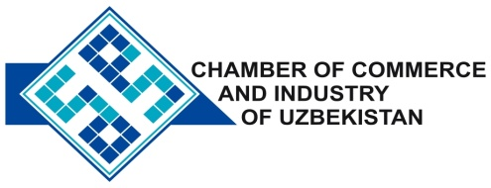

**Commercial offer of Uzbek Products to Foreign Buyer**

Dear Sirs, FM - 001

We offer quotation of Uzbek Company «Uzmetkombinat».

Information about the company:

The company "Uzmetkombinat" was founded in 1944. The company's main activity is the production of long steel, brass and copper strips, as well as the steel enameled utensils.

**List of products:**

|  |  |  |  |  |
| --- | --- | --- | --- | --- |
| No | Name of product | | | EMK. per liter |
| 1 | Dish | | | 1.5- 4.5 |
| 2 | cylindrical pans with lid | | | 5-12 |
| 3 | Mantyshnitsa | | | 12-16 |
| 4 | Buck | | | 16 |
| 5 | Maker | | | 2-3.5 |
| 6 | Taz | | | 12-16 |
| 7 | Mug | | | 0.4-1 |
| 8 | Bowl | | | 0.8-5 |
| 9 | A bucket with a lid | | | 12 |
| 10 | Coffee | | | 1.5 |
| 11 | cans of cover | | | 2-6 |
| 12 | Bucket | | | 1.5 |
| 13 | Night pot | | | 1.5 |
| 14 | Salad | | | 1.5 |
| The size | | | | |
| 15 | | bolt from | M5 to M8 * 40 * 55 | |
| 16 | | Nut | M8 * from 1.25 to | |
| 17 | | Up to | M16 * 2 | |

**Benefits:**

High strength, excellent appearance and high quality.

**Terms of delivery:** FCATashkent

If you are interested, we are happy to provide additional information in accordance with your request.

E-mail: export@chamber.uz

Website: www.chamber.uz

Export Promotion Department .

Chamber of Commerce of the Republic of Uzbekistan .