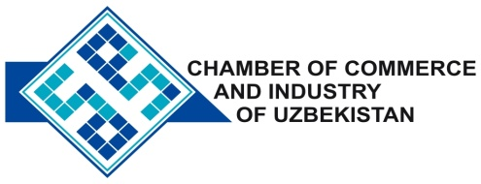

**Commercial offer of Uzbek Products to Foreign Buyer**

Dear Sirs, №TP - 028

We offer quotation of Uzbek Company JV «SilverSilkcompany».

**Information about the company:**

The company «SilverSilkcompany» was founded in 2004. The company specializes in the processing of silk waste.

**List of products:**

Natural silk ribbon

**Benefits:**

100 % natural silk , top quality .

**Terms of delivery:** FCA Tashkent

If you are interested, we are happy to provide additional information in accordance with your request.

E-mail: export@chamber.uz

Website: www.chamber.uz

Export Promotion Department.

Chamber of Commerce of the Republic of Uzbekistan.