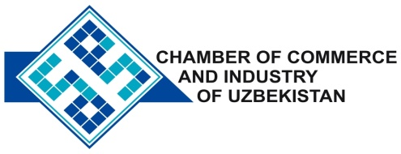

**Commercial offer of Uzbek Products to Foreign Buyer**

Dear Sirs, MLPPBP-004

We offer quotation of Uzbek Company JSC "Onyx"

**Information about the company:**

The company "Onyx" for more than thirty years of experience in the production of crystal products, and specializes in manufacturing assorted glassware (vases, bowls, wine glasses, wine glasses, plates, etc.) and lighting equipment of different modifications (chandeliers, sconces and. Etc. ).

**List of products:**

Technical Specifications Products from crystal

Assorted glassware tableware, crystal trophies and cups, a wide range of chandeliers and sconces.

Scope of the consumer goods, buildings and institutions

**Benefits:**

Current products of the company is not inferior to the quality and design of similar imported products of leading world manufacturers , and at the same time compares favorably with reasonable price .

**Terms of delivery:** FCA Tashkent

If you are interested, we are happy to provide additional information in accordance with your request.

E-mail: [export@chamber.uz](mailto:export@chamber.uz)

Website: [www.chamber.uz](http://www.chamber.uz)

Export Promotion Department .

Chamber of Commerce of the Republic of Uzbekistan .