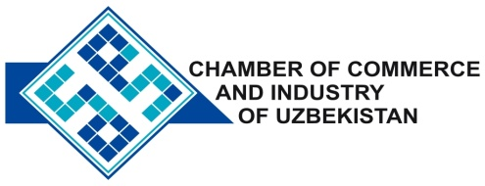

**Commercial offer of Uzbek Products to Foreign Buyer**

Dear Sirs, №KMOP-001

We offer quotation of Uzbek Company JV «PENGSHENG».

**Information about the company:**

Company «PENGSHENG» was founded in 2009. The company specializes in the processing of raw leather, manufacture of shoes and a variety of materials.

**List of products:**

A natural skin

Footwear

Ceramic Tiles

**Benefits:**

Focused on high quality of products -Works on the principle that the use of innovative technology, continuous development and improvement of product quality in order to mutually beneficial cooperation with our customers.

**Terms of delivery:** FCA Tashkent

If you are interested, we are happy to provide additional information in accordance with your request.

E-mail: [export@chamber.uz](mailto:export@chamber.uz)

Website: [www.chamber.uz](http://www.chamber.uz)

Export Promotion Department.

Chamber of Commerce of the Republic of Uzbekistan.