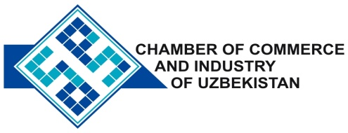

**Commercial offer of Uzbek Products to Foreign Buyer**

Dear Sirs, №NP - 002

We offer quotation of Uzbek Company Ltd «BERUNIYTAL'K».

**Information about the company:**

The company «BERUNIYTAL'K» was founded in 2009. The Company is engaged in mining and processing of talc ground and microtals. The company's products are widely used in all industrial sectors : paint , rubber , metal, chemical , ceramic , plastic , as well as in the manufacture of coatings , polystyrene , roofing materials , electrodes , etc.

**List of products:**

Talkmagnizit hammers brand TMN, TMP.

Mineral powder Make IPA.

Talc cable Brand TK- 1GOST 13145-67.

Talc ceramic Brand TMK 27 TMK - 28.

Micro talc for the paint industry GOST 19284-79.

Talc rubber Mark TRPV, TRPN , GOST 19729-74 .

**Benefits:**

A distinctive feature of the technology used and the uniqueness of the company there is a deep cleansing of impurities from the feedstock and achieved consistently uniform physical and chemical composition of the finished product . Uniformity talc, Purity fundamentally affect the quality of its application in various industries. Therefore, the majority of enterprises of Uzbekistan and the CIS , observing the high quality of their products , consumers are «BERUNIYTAL'K» LLC .

**Terms of delivery:** FCA Tashkent

If you are interested, we are happy to provide additional information in accordance with your request.

E-mail: [export@chamber.uz](mailto:export@chamber.uz)

Website: [www.chamber.uz](http://www.chamber.uz)

Export Promotion Department.

Chamber of Commerce of the Republic of Uzbekistan