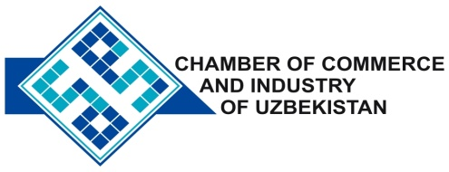

**Commercial offer of Uzbek Products to Foreign Buyer**

Dear Sirs, MP-004

We offer quotation of Uzbek Company «ART-METALL» Ltd.

**Information about the company:**

The company «ART-METALL» was founded in 2005. The company specializes in the manufacture of furniture.

**List of products:**

Furniture range

**Benefits:**

The company offers a wide range of furniture and accessories of own production for hotels, rest houses, children's, educational and other institutions. Buying furniture companies, you get convenient, comfortable furniture that will fit into the interior of your cafe, restaurant and hotel.

**Terms of delivery:** FCA Tashkent

If you are interested, we are happy to provide additional information in accordance with your request.

E-mail: [export@chamber.uz](mailto:export@chamber.uz)

Website: [www.chamber.uz](http://www.chamber.uz)

Export Promotion Department.

Chamber of Commerce of the Republic of Uzbekistan.