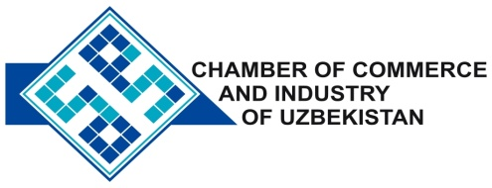

**Commercial offer of Uzbek Products to Foreign Buyer**

Dear Sirs, NP-001

We offer quotation of Uzbek Company Ltd «DIRICHMEGAOIL».

**Information about the company:**

Company «DIRICHMEGAOIL» was founded in 2007. The company's main activity is the production of lubricants in the range of technical needs.

**List of products:**

Sol idol (F) GOST 1033-79

Litol - 24

Grease 1-13 Tsh 64-21469190-001: 2008

**Benefits:**

The advantages of their use - provides excellent lubricity and high load-bearing capacity of the product, as well as protection from jamming friction pairs at high loads.

**Terms of delivery:** EXW Tashkent

If you are interested, we are happy to provide additional information in accordance with your request.

E-mail: [export@chamber.uz](mailto:export@chamber.uz)

Website: [www.chamber.uz](http://www.chamber.uz)

Export Promotion Department.

Chamber of Commerce of the Republic of Uzbekistan.