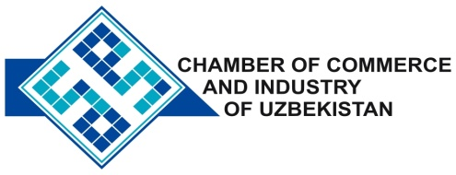

**Commercial offer of Uzbek Products to Foreign Buyer**

Dear Sirs, KP-025

We offer quotation of the Uzbek Company Ltd «MATETASHKENT»

**Information about the company:**

The company "MATETASHKENT" was founded in 2008. The company specializes in the manufacture and sale of consumables used in the operation of vehicles for different purposes, from cars to buses and heavy trucks.

**List of products:**

Antifreeze

Windscreen wipers

Autoshampooes

**Benefits:**

Antifreeze - one of the components that we fill the car. Without proper cooling cannot be trouble-free operation "heart" of the car - its engine.

**Terms of delivery:** FCA Tashkent

If you are interested, we are happy to provide additional information in accordance with your request.

E-mail: [export@chamber.uz](mailto:export@chamber.uz)

Website: [www.chamber.uz](http://www.chamber.uz)

Export Promotion Department.

Chamber of Commerce of the Republic of Uzbekistan.