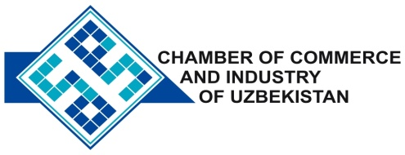

**Commercial offer of Uzbek Products to Foreign Buyer**

Dear Sirs, №TP - 035

We offer quotation of the Uzbek Company LTD «O'ZFANT»

**Information about the company:**

The company "O'ZFANT" founded in 1992. The company is a manufacturer of canvas.

**List of products:**

Fabric Technology severe «Sailcloth»

Cloth dyed technical «Sailcloth»

**Benefits:**

Features of this popular fabric are well known: excellent quality, reasonable price.

**Terms of delivery:** FCA Tashkent

If you are interested, we are happy to provide additional information in accordance with your request.

E-mail: export@chamber.uz

Website: www.chamber.uz

Export Promotion Department.

Chamber of Commerce of the Republic of Uzbekistan.