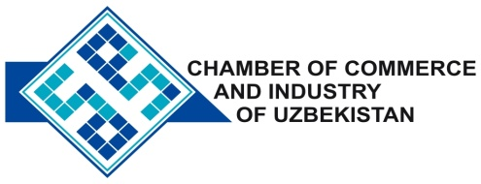

**Commercial offer of Uzbek Products to Foreign Buyer**

Dear Sirs, №TP-046

We offer quotation of the Uzbek joint venture company LTD «UZTEXTASHKENT».

**Information about the company:**

The company "UZTEXTASHKENT" was founded in 2010. The Company engaged in the production of yarn carded and combed spinning methods.

**List of products:**

Waste spinning Art. 16 (oil) at a price of 1.70 US dollars

**Benefits:**

The company is the latest in Uzbekistan, and is equipped with the most modern equipment of firms that are world leaders in the production of textile machinery.

**Terms of delivery:** FCA Tashkent

If you are interested, we are happy to provide additional information in accordance with your request.

E-mail: export@chamber.uz

Website: www.chamber.uz

Export Promotion Department.

Chamber of Commerce of the Republic of Uzbekistan.