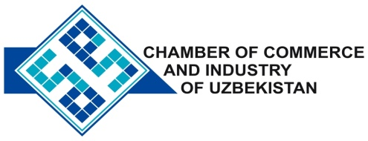

**Commercial offer of Uzbek Products to Foreign Buyer**

Dear Sirs, M-005

We offer quotation of Uzbek Company Ltd "SREDAZPODSHIPNIK"

**Information about the company:**

The company "SREDAZPODSHIPNIK" was founded in 2009. The company's main activity is the production of ball, roller and spherical bearings in more than 1,500 items. Manufactured products are used in various sectors: automotive, railway, electrical, chemical and metallurgical industries. Industry produces 20gramm of up to 2.5 tons.

**Benefits:**

The company produces the optimal bearings according to the conditions of operation and cost.

**Terms of delivery:** FCA Tashkent

If you are interested, we are happy to provide additional information in accordance with your request.

E-mail: [export@chamber.uz](mailto:export@chamber.uz)

Website: [www.chamber.uz](http://www.chamber.uz)

Export Promotion Department.

Chamber of Commerce of the Republic of Uzbekistan.