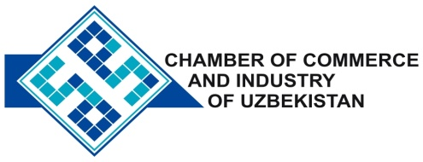

**Commercial offer of Uzbek Products to Foreign Buyer**

Dear Sirs, №KMOP - 005

We offer quotation of Uzbek Company Ltd «HAMKORNURSAVDO».

**Information about the company:**

The company «HAMKORNURSAVDO» is registered in the public register of the Republic of Uzbekistan September 9, 2004. The main activity - production of leather and leather semi- wet blue of cattle and small cattle skins.

**List of products:**

A natural skin

Semi-finished leather from cattle and small cattle skins.

**Benefits:**

Currying carried out in accordance with the requirements

**Terms of delivery:** FCA Tashkent

If you are interested, we are happy to provide additional information in accordance with your request.

E-mail: [export@chamber.uz](mailto:export@chamber.uz)

Website: [www.chamber.uz](http://www.chamber.uz)

Export Promotion Department.

Chamber of Commerce of the Republic of Uzbekistan.