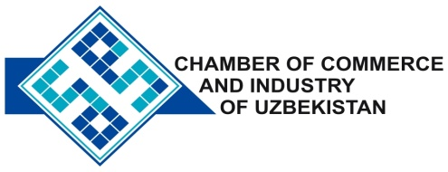

**Commercial offer of Uzbek Products to Foreign Buyer**

Dear Sirs, №AP - 004

We offer quotation of Uzbek Company PE «STEELBEARING».

**Information about the company:**

Company «STEELBEARING» was founded in 2010 specializes. The company is manufacturing bearing more than 1500 names.

**List of products:**

Bearings

**Benefits:**

Enterprise is organized in accordance with international standards and found to be effective.

**Terms of delivery:** FCA Tashkent

If you are interested, we are happy to provide additional information in accordance with your request.

E-mail: [export@chamber.uz](mailto:export@chamber.uz)

Website: [www.chamber.uz](http://www.chamber.uz)

Export Promotion Department.

Chamber of Commerce of the Republic of Uzbekistan.