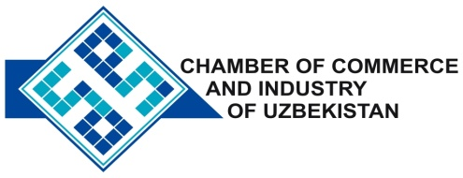

**Commercial offer of Uzbek Products to Foreign Buyer**

Dear Sirs, №HP-008

We are pleased to offer you products of the company "Ferganaazot".

**Information about the company:**

Company Ltd "Ferganaazot" specializes in the production of mineral fertilizers and inorganic substances. Most of the products are exported to the CIS countries and others. (Russia, Lithuania, Kazakhstan, Kyrgyzstan, Tajikistan, Turkmenistan, the Baltic countries, China, Iran).

**List of products:**

liquid ammonia Ammonium nitrate granulated granular urea The crystalline sodium chlorate Magnesium chlorate defoliant (liquid) cellulose diacetate

**Terms of delivery:** FCA st.Kirgili UTI

If you are interested, we are happy to provide additional information in accordance with your request.

E-mail: [export@chamber.uz](mailto:export@chamber.uz)

Website: [www.chamber.uz](http://www.chamber.uz)

Export Promotion Department.

Chamber of Commerce of the Republic of Uzbekistan.