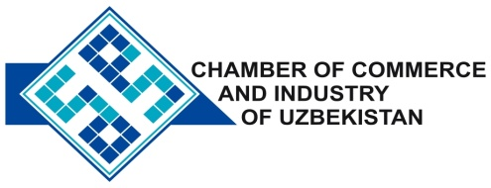

**Commercial offer of Uzbek Products to Foreign Buyer**

Dear Sirs, №KMOP - 002

We offer quotation of Uzbek companies Ltd «ANDIJONCHARM».

**Information about the company:**

Company «ANDIJONCHARM» was founded in 2010. The company specializes in the processing of leather, manufacture of leather products.

**List of products:**

Leather Leather products (jackets, bags, leather shoes)

**Benefits:**

The company's products are of high quality and durability.

**Terms of delivery:** FCA Tashkent

If you are interested, we are happy to provide additional information in accordance with your request.

E-mail: [export@chamber.uz](mailto:export@chamber.uz)

Website: [www.chamber.uz](http://www.chamber.uz)

Export Promotion Department.

Chamber of Commerce of the Republic of Uzbekistan.