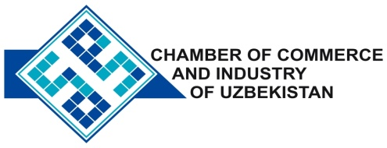

**Commercial offer of Uzbek Products to Foreign Buyer**

Dear Sirs, IVS - 006

We offer quotation of the Uzbek joint venture company “MYLOVELYASIA»

**Information about the company:**

The Company "MYLOVELYASIA" was founded in 2008 for the production of consumer goods.

**List of products:**

Washing powder

Shampoo

Detergent soap

Detergents: Dishwashing

Gel for washing dishes

cleaner

Glue

**Benefits:**

The company's goal is to benefit society by offering modern, effective and high-quality products

**Terms of delivery:** FCA Tashkent

If you are interested, we are happy to provide additional information in accordance with your request.

E-mail: [export@chamber.uz](mailto:export@chamber.uz)

Website: [www.chamber.uz](http://www.chamber.uz)

Export Promotion Department.

Chamber of Commerce of the Republic of Uzbekistan.